**SPLUNK**

**Splunk Beginner to Architect**

**Section 14: Advanced Splunk Concepts:**

1. **Using Btool for Troubleshooting:**

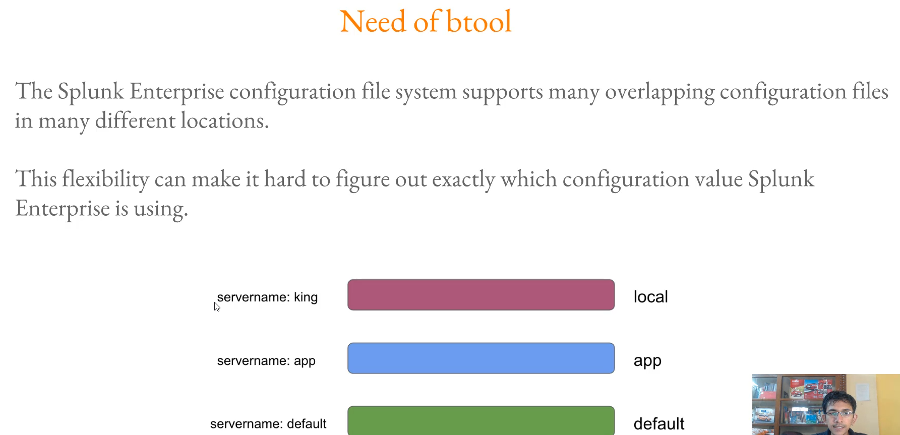

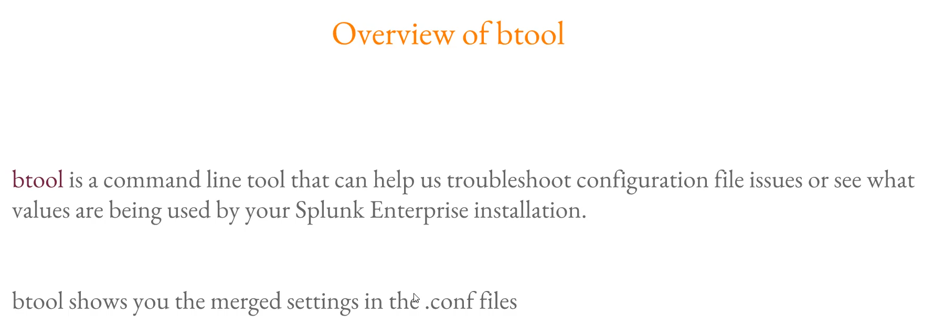

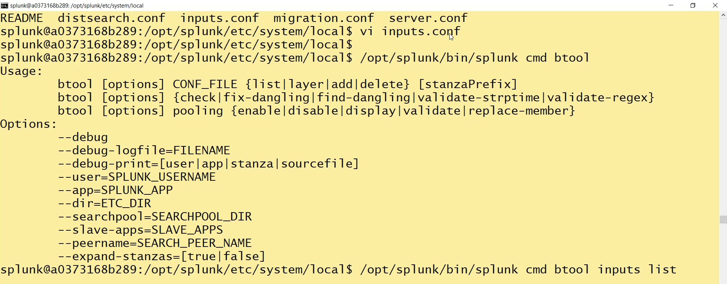

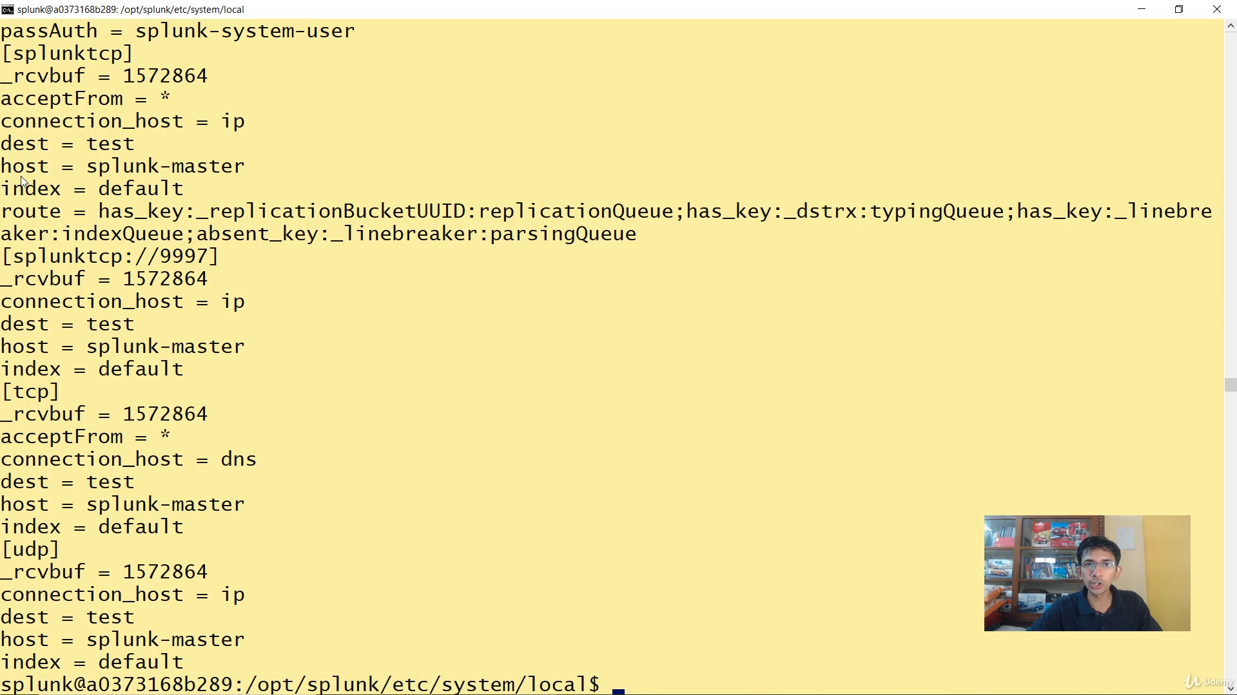

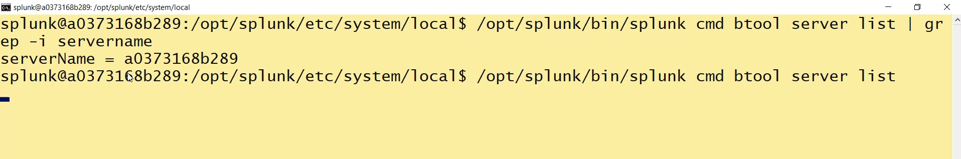

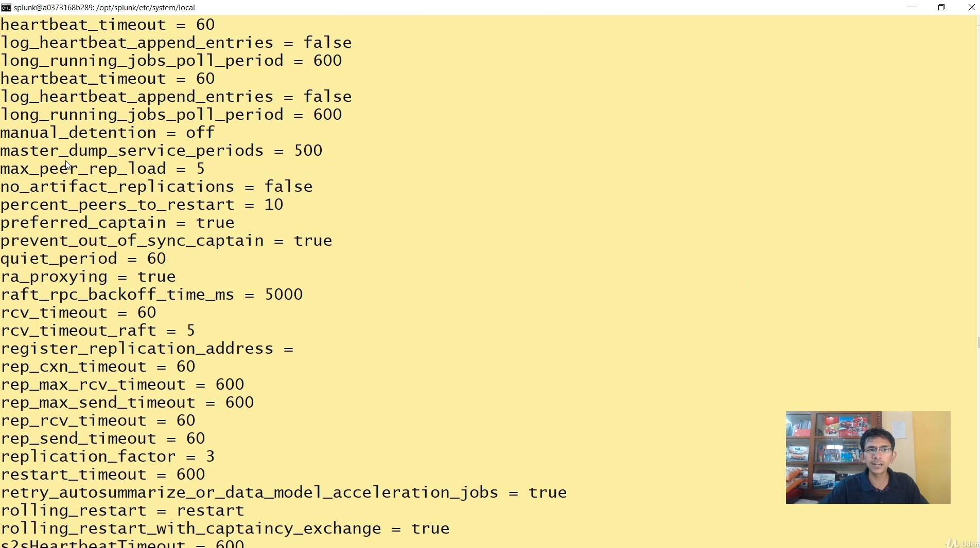



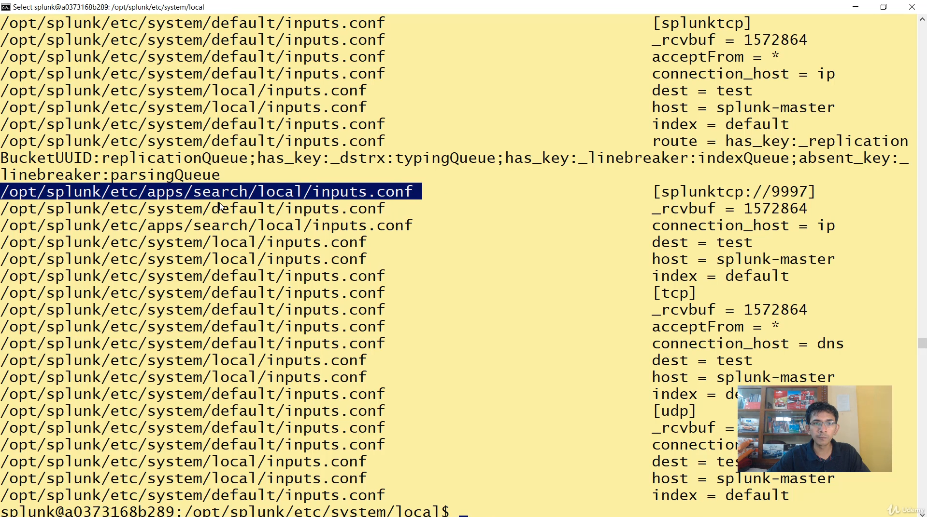

**Splunk BTool Utility Summary**

The **BTool** (splunk btool) is a command-line utility essential for **troubleshooting** Splunk configuration issues. Its primary purpose is to show the merged, final configuration settings that Splunk Enterprise is actively using, respecting all configuration file precedence rules.

**1. Why BTool is Necessary (Configuration Precedence)**

* Splunk supports many overlapping configuration files (.conf) that can exist in multiple locations (e.g., default/, local/, app directories).
* When the same setting appears in multiple files, Splunk applies **precedence** rules (e.g., local always overrides default).
* **BTool's Function:** It merges all these files based on precedence and shows the single, final value Splunk has selected for a setting. This helps identify *which file* is supplying an unexpected value.

**2. Key BTool Commands**

The core BTool command structure is: $SPLUNK_HOME/bin/splunk cmd btool <conf_file_name> <action>

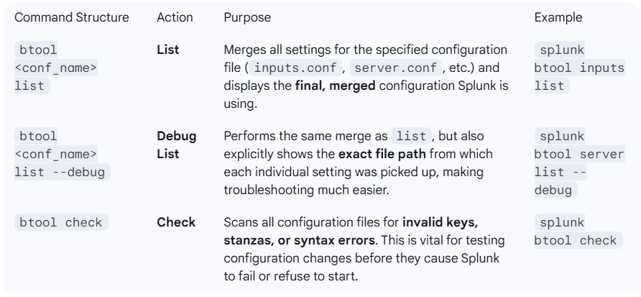

**3. Practical Demonstrations**

**Checking Merged Settings (The list command)**

* To see the final configuration for inputs.conf, the command used was splunk cmd btool inputs list.
* To see the final configuration for server.conf, the command used was splunk cmd btool server list.
  + **Note:** You must specify the configuration file name *without* the .conf extension (e.g., inputs, not inputs.conf).

**Identifying Source File (The --debug option)**

* Using splunk cmd btool <conf_name> list --debug displays the final setting along with the file path (e.g., $SPLUNK_HOME/etc/system/local/server.conf) that supplied that specific value. This is the most effective troubleshooting option.

**Validating Configuration (The check command)**

* The instructor demonstrated adding an invalid key (DEST=DSD) to inputs.conf.
* Running splunk btool check immediately identified the error: **"invalid key in the stanza [default] in... inputs.conf"** and displayed the exact line number, allowing for quick correction.

**============================================================================**

1. **Overview of Data models:**

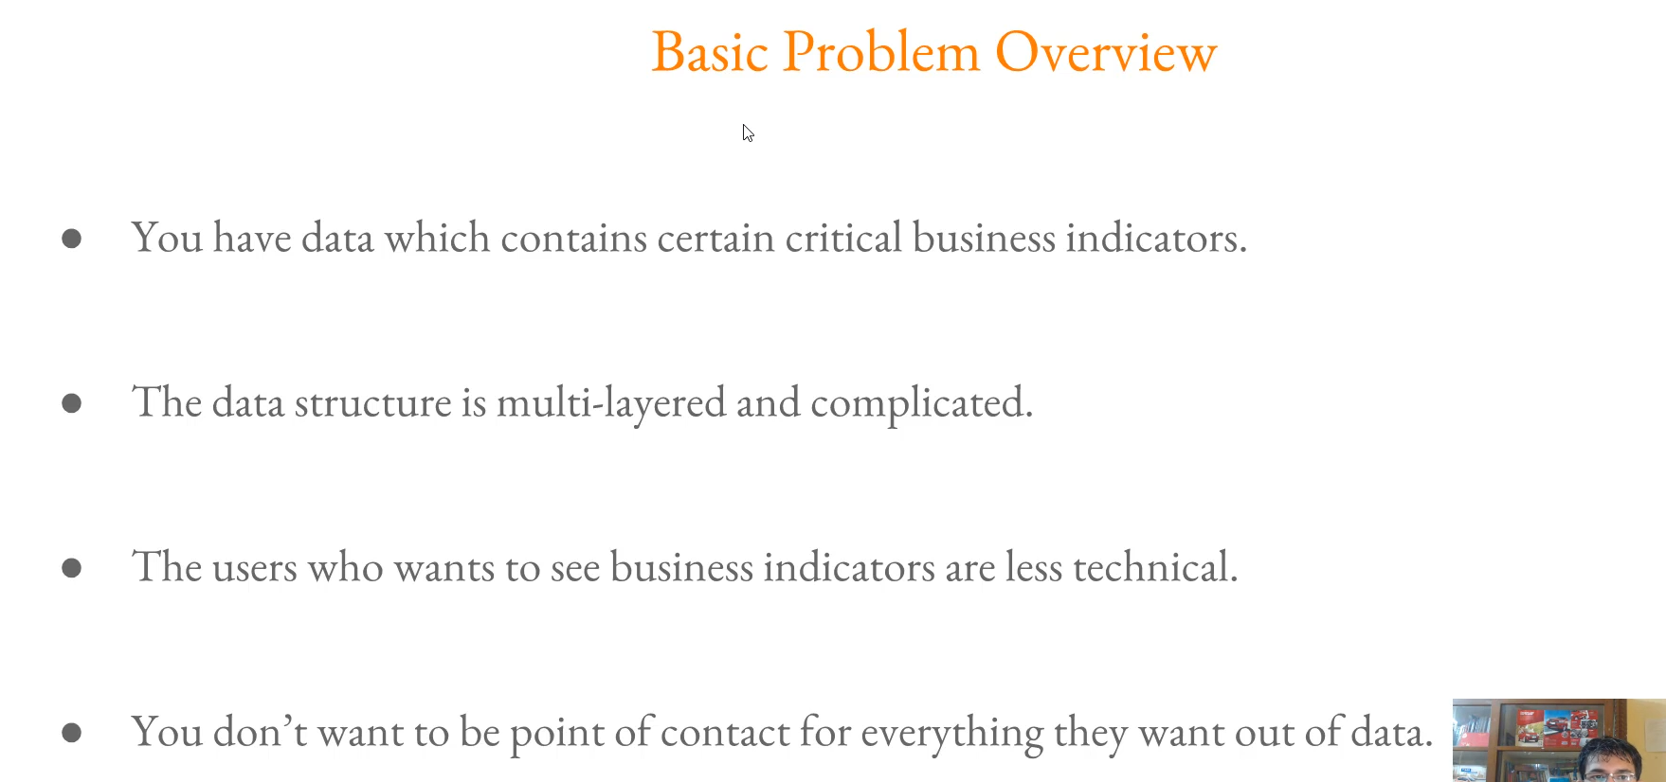

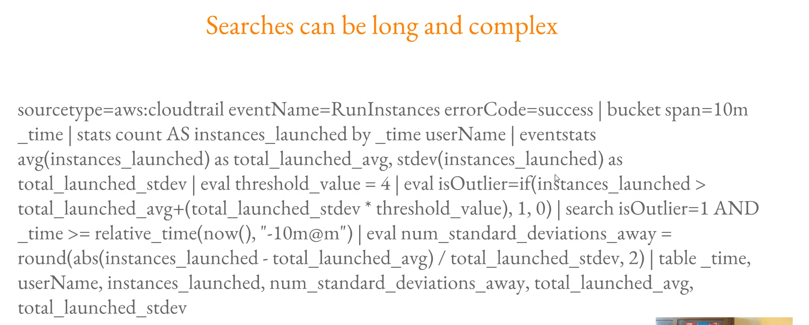

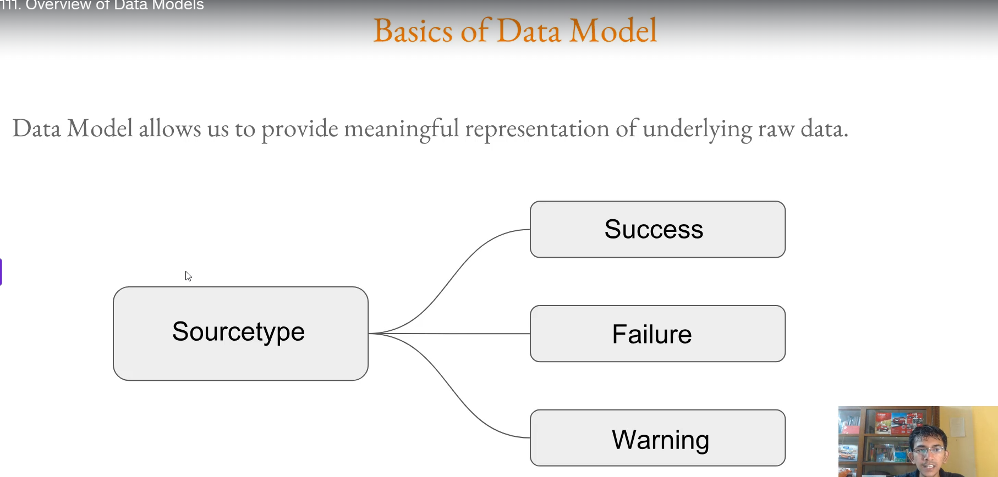

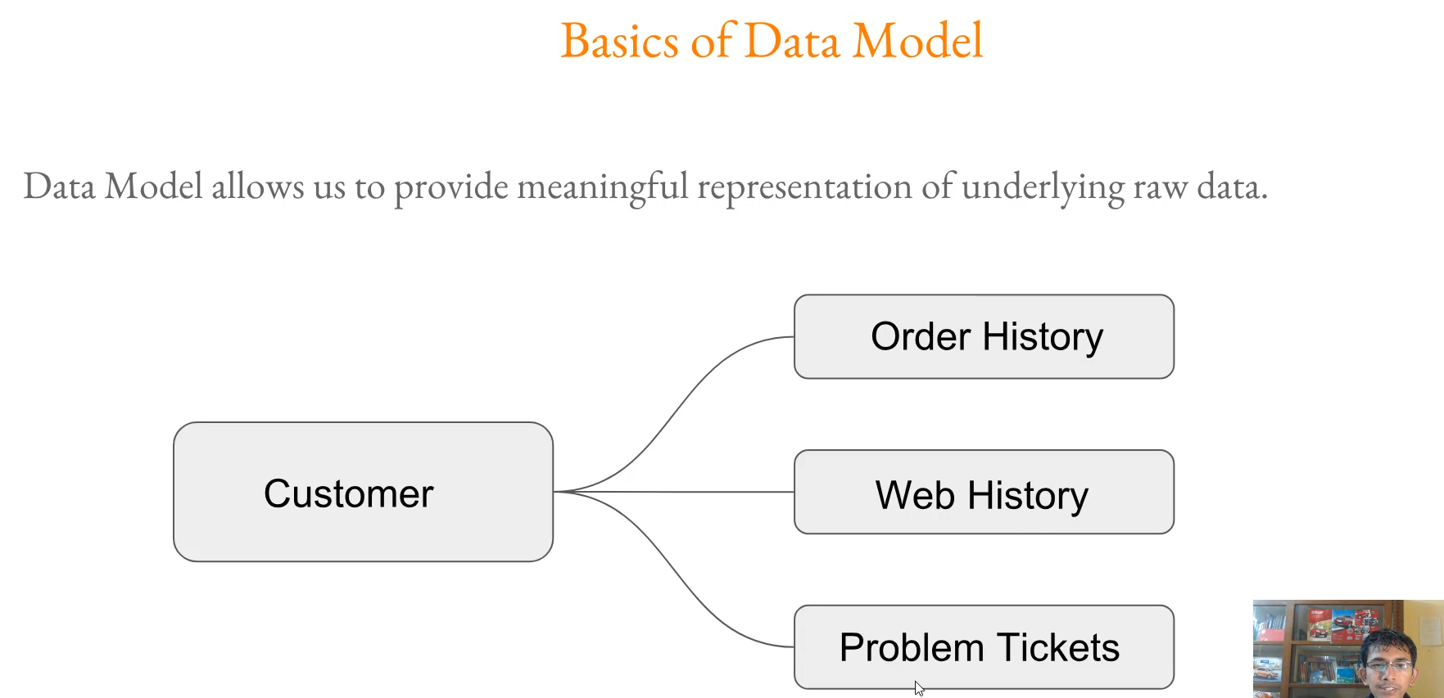

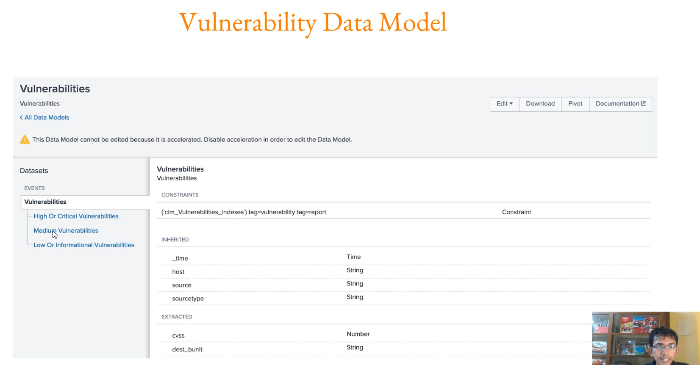

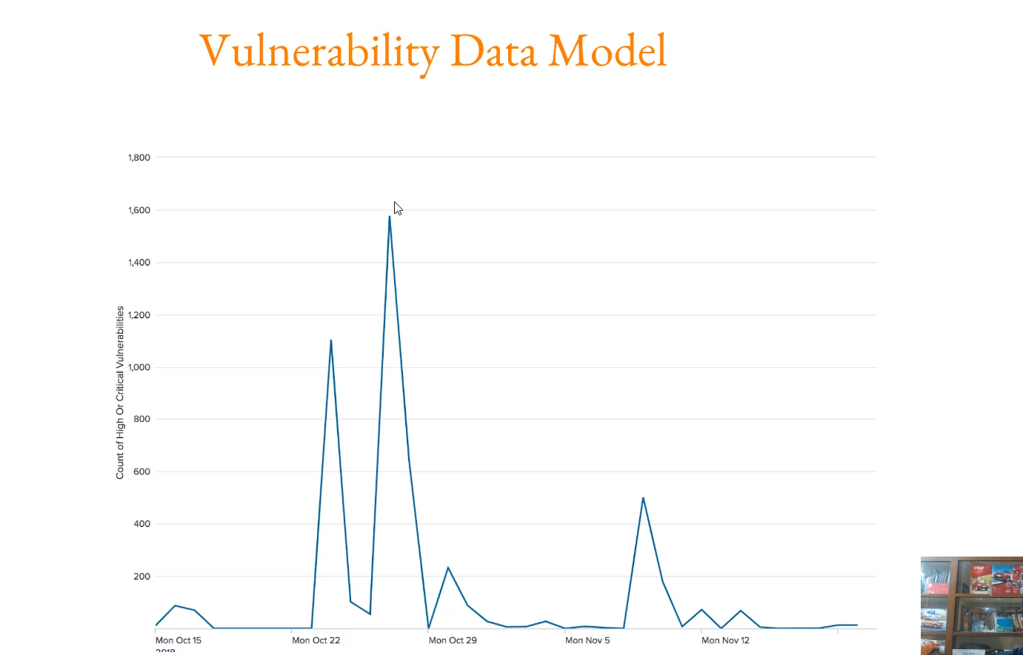

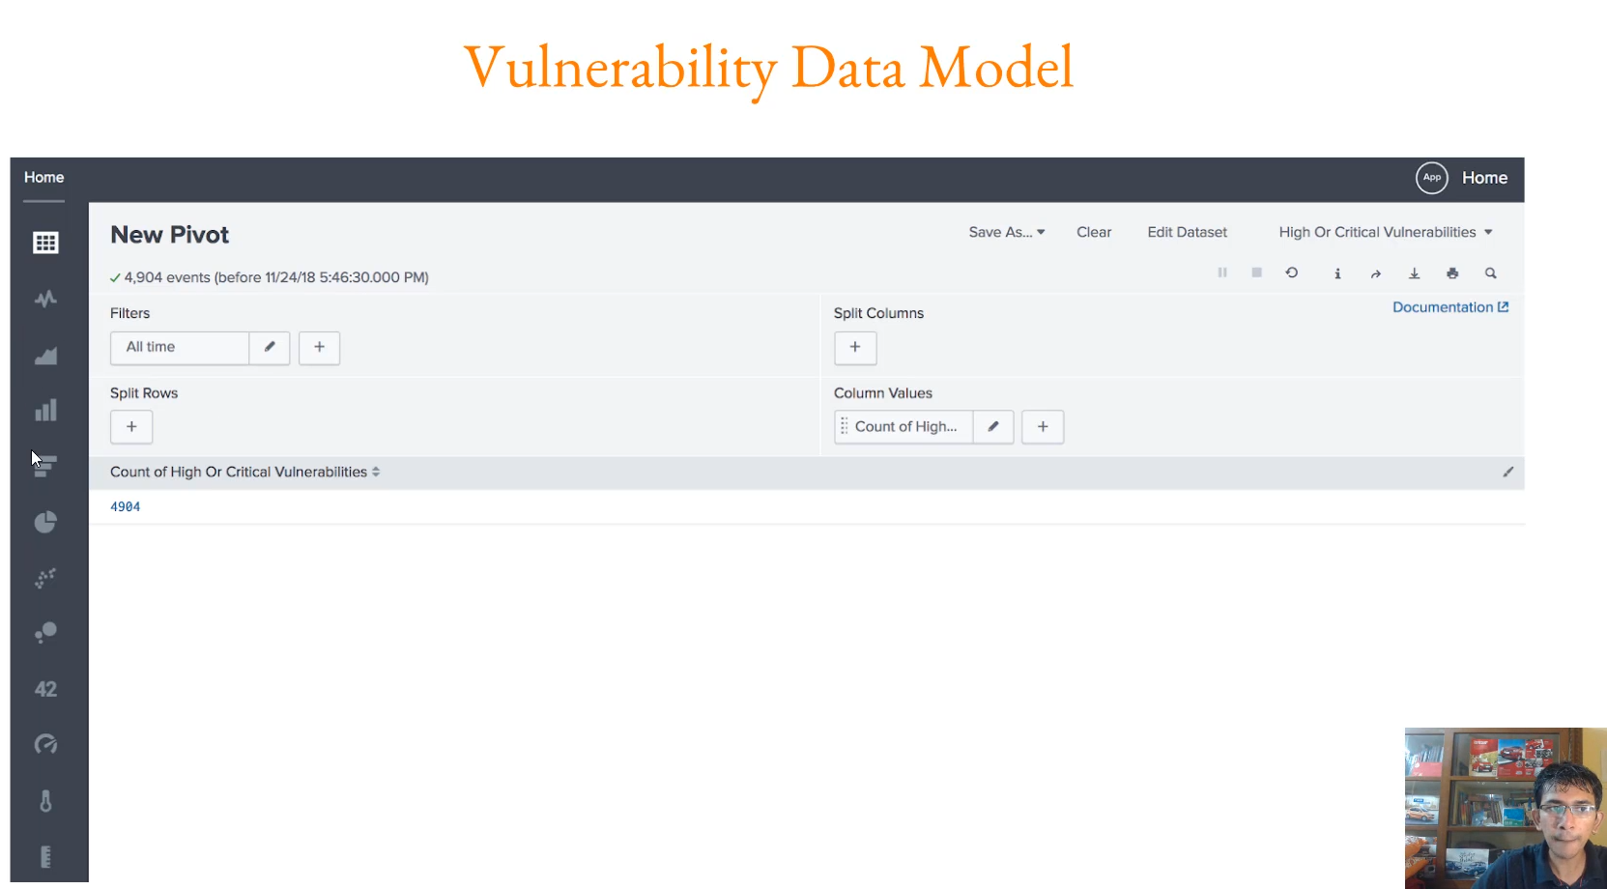

**Splunk Data Model Functionality Overview**

The primary purpose of a Splunk Data Model is to simplify complex, raw data structures into meaningful, accessible representations that less technical users can easily query and visualize without writing complex Search Processing Language (SPL) commands.

**1. The Core Problem Data Models Solve**

* **Complicated Data:** Organizations often index data that is multi-layered and complicated, containing critical business indicators that are hard to extract directly.
* **Non-Technical Users:** The users who need to analyze this critical data are often less technical and may not be masters of SPL.
* **The Conflict:** These users cannot write the complex, long search queries required to extract meaningful information from the underlying data structure. This places an unnecessary burden on technical experts (Splunk Admins) to write all the necessary reports.

**2. What is a Data Model?**

A Data Model acts as an **abstraction layer** that imposes a logical structure onto the raw, underlying data.

* **Meaningful Information:** It organizes data into a hierarchy of datasets that represent a specific context or business indicator.
* **Simple Structure:** Instead of seeing complicated event structures, the user sees a simplified hierarchy (e.g., a "Customer" model divided into "Order History," "Web History," and "Problem Tickets").
* **Subsets:** Data models are often divided into subsets (or root events) based on a common field or condition (e.g., a "Vulnerability" model divided into "High/Critical," "Medium," and "Low").

**3. The User Experience: Pivoting**

The key benefit of a Data Model is enabling **Pivoting**, a highly simplified data analysis workflow.

* **Point-and-Click:** The user, without writing any SPL, simply **points and clicks** on the desired data subset within the model (e.g., clicking the "High/Critical Vulnerability" subset).
* **Automatic Dashboarding:** Clicking a subset automatically takes the user to a **Pivoting page**, which shows counts and can **automatically generate visualizations and dashboards** based on the structured data model fields.
* **Result:** A less technical user can easily retrieve highly relevant data (like the count and trend of critical vulnerabilities) just by using a simple graphical interface.

**============================================================================**

1. **Creating data models:**

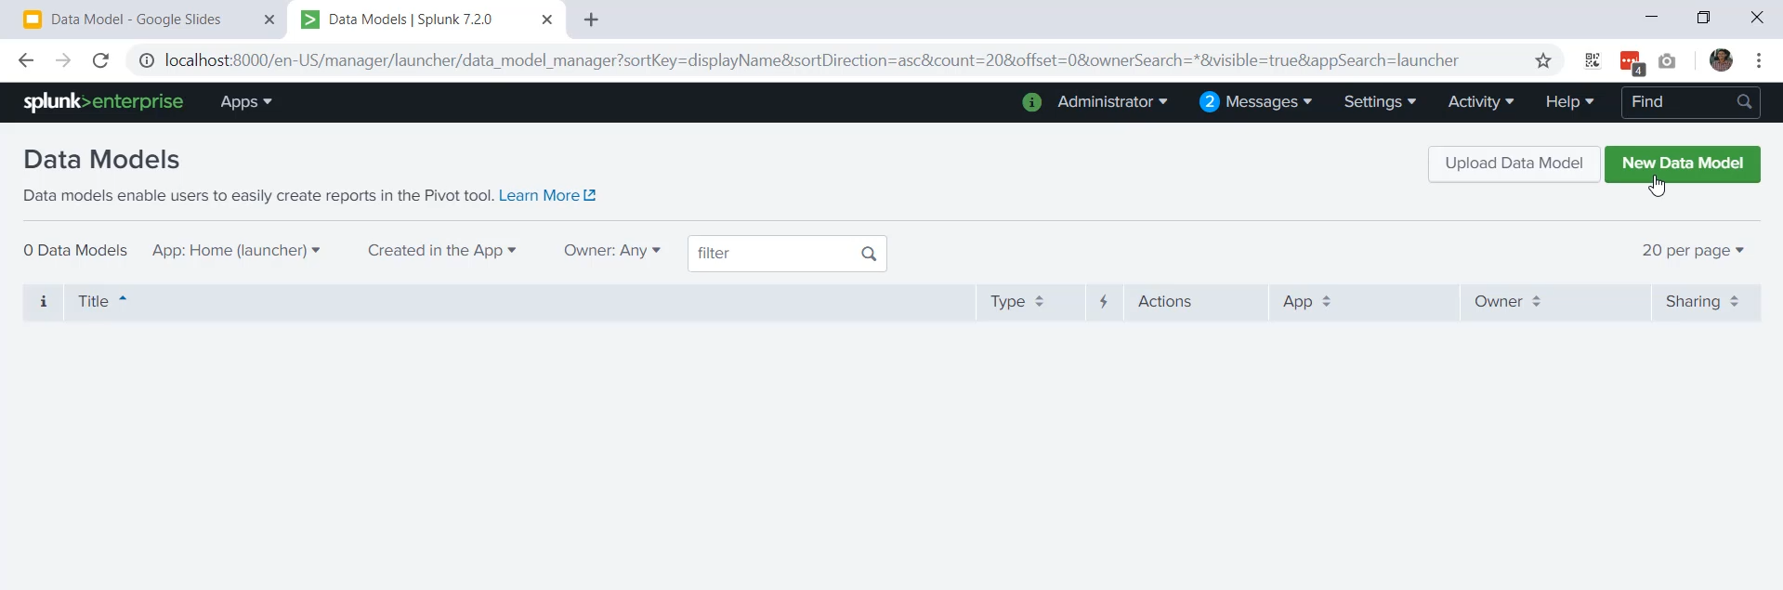

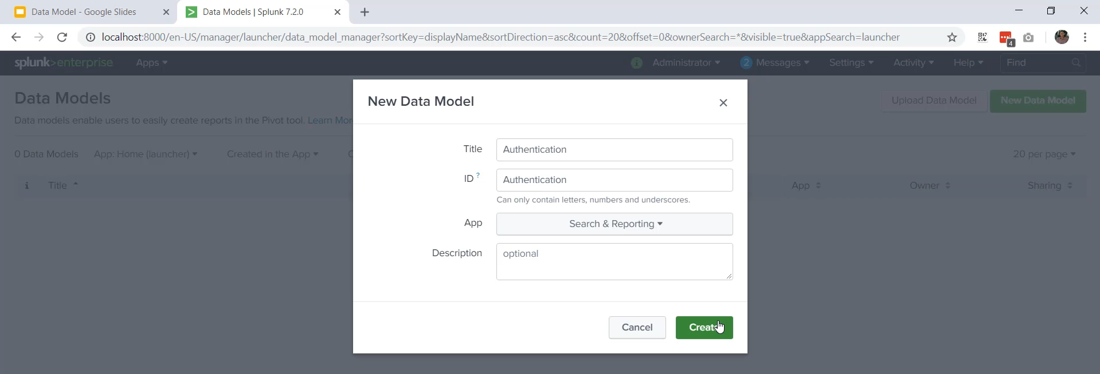

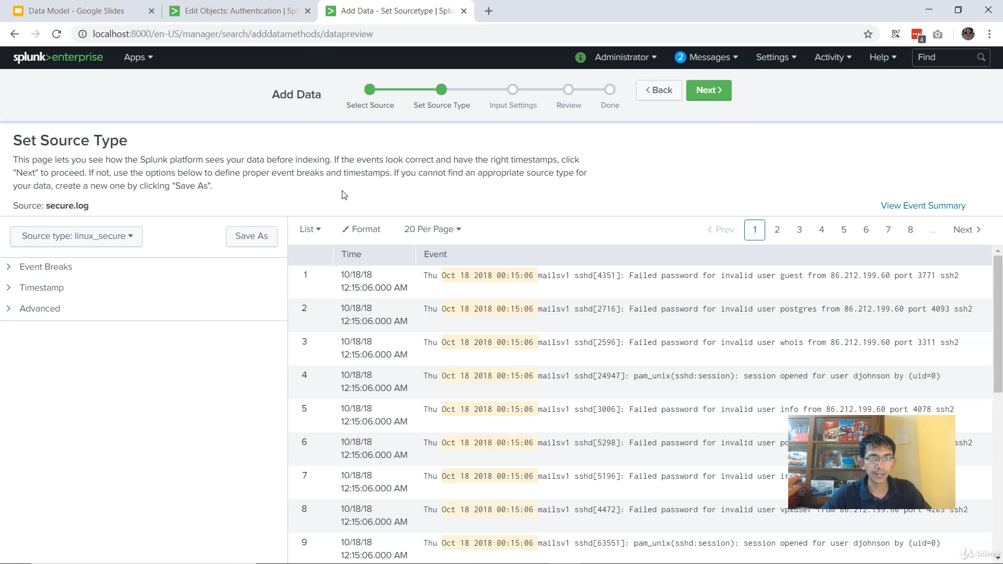

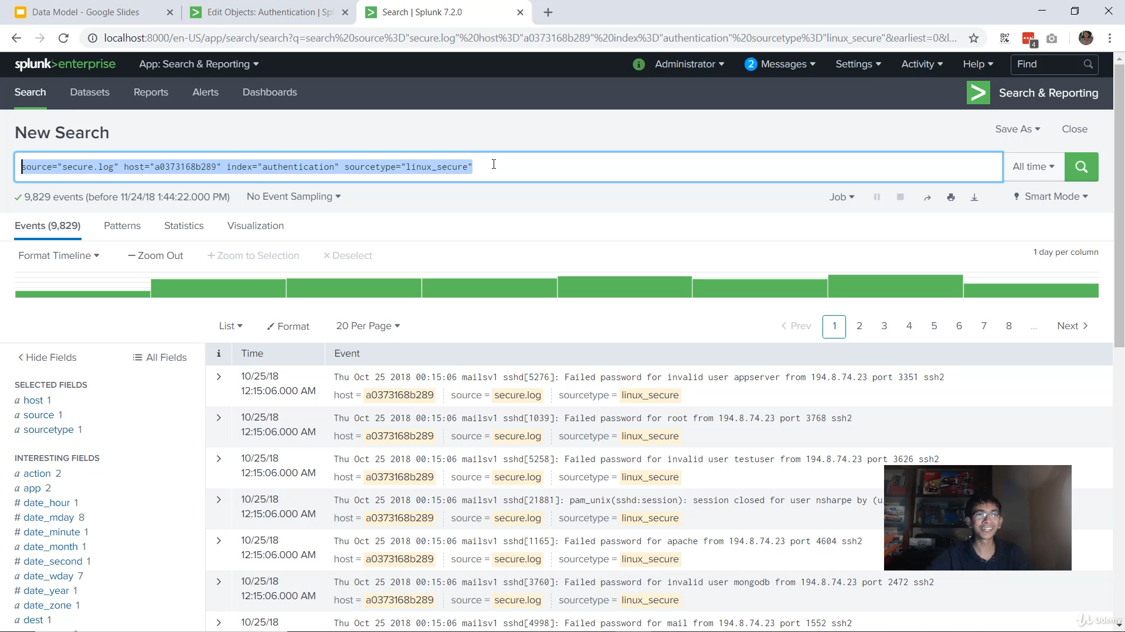

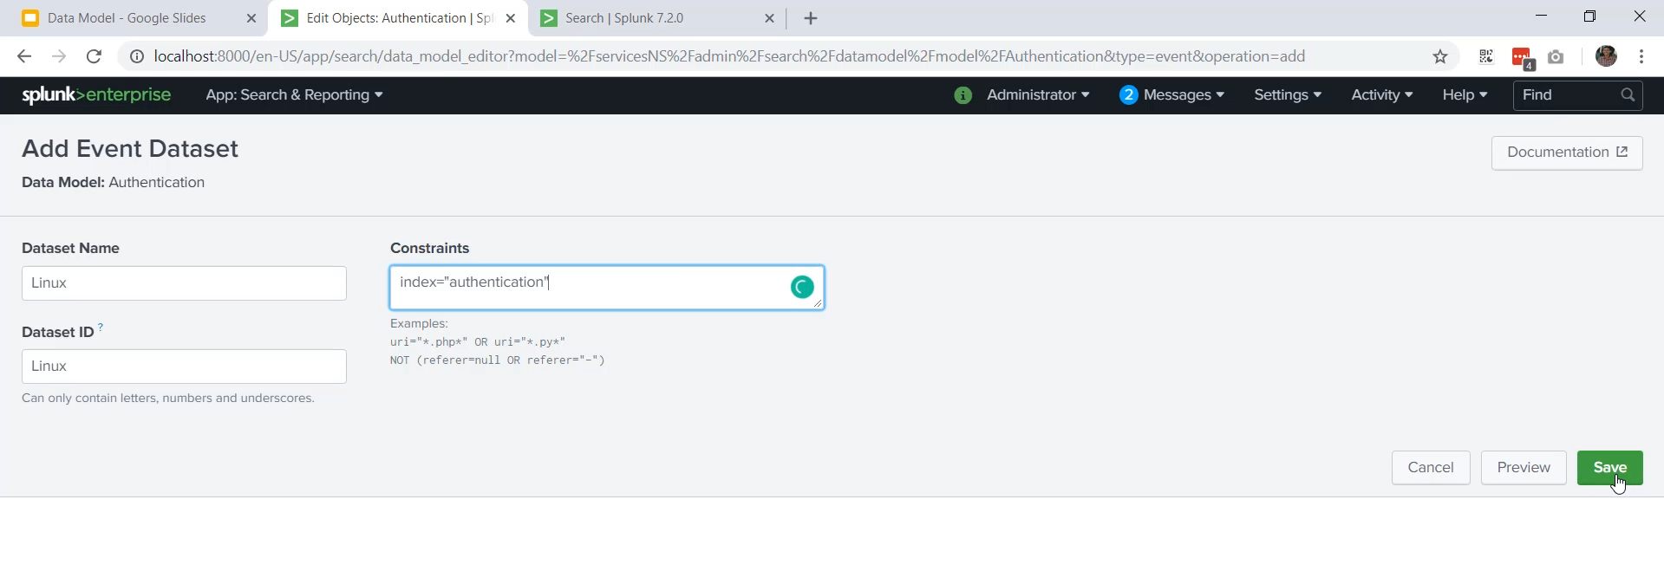

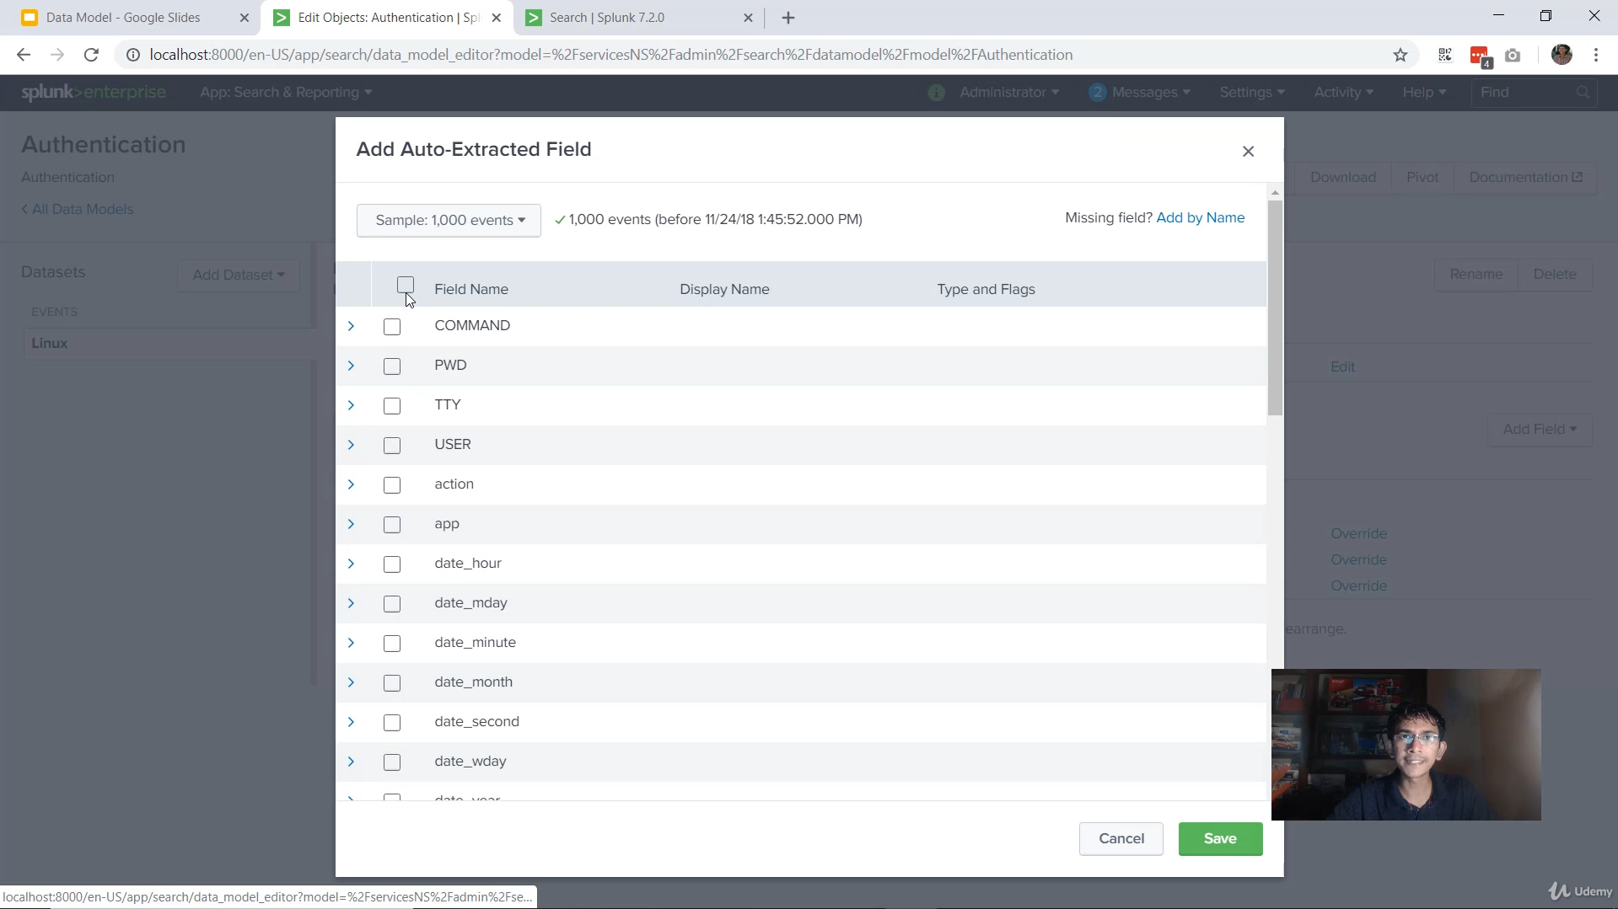

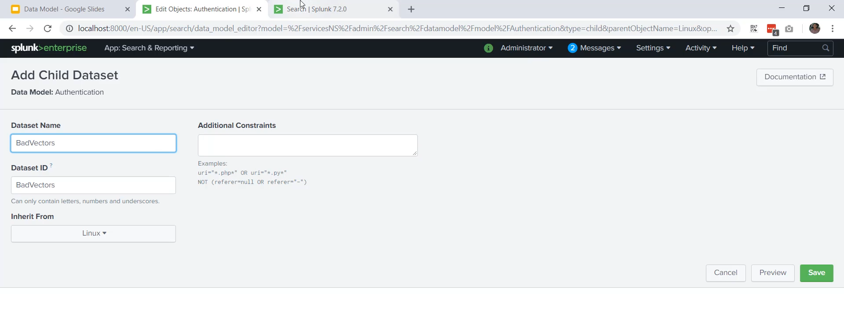

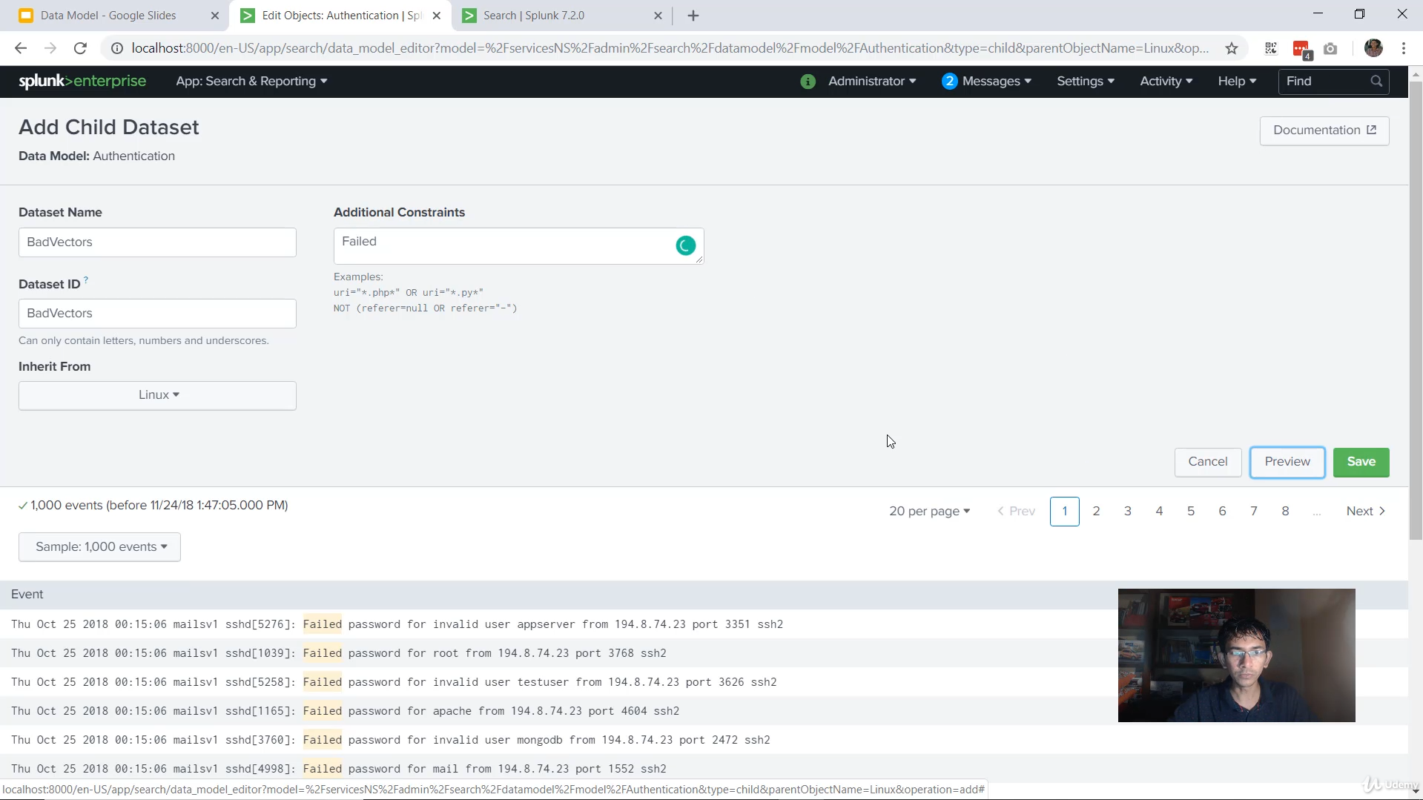

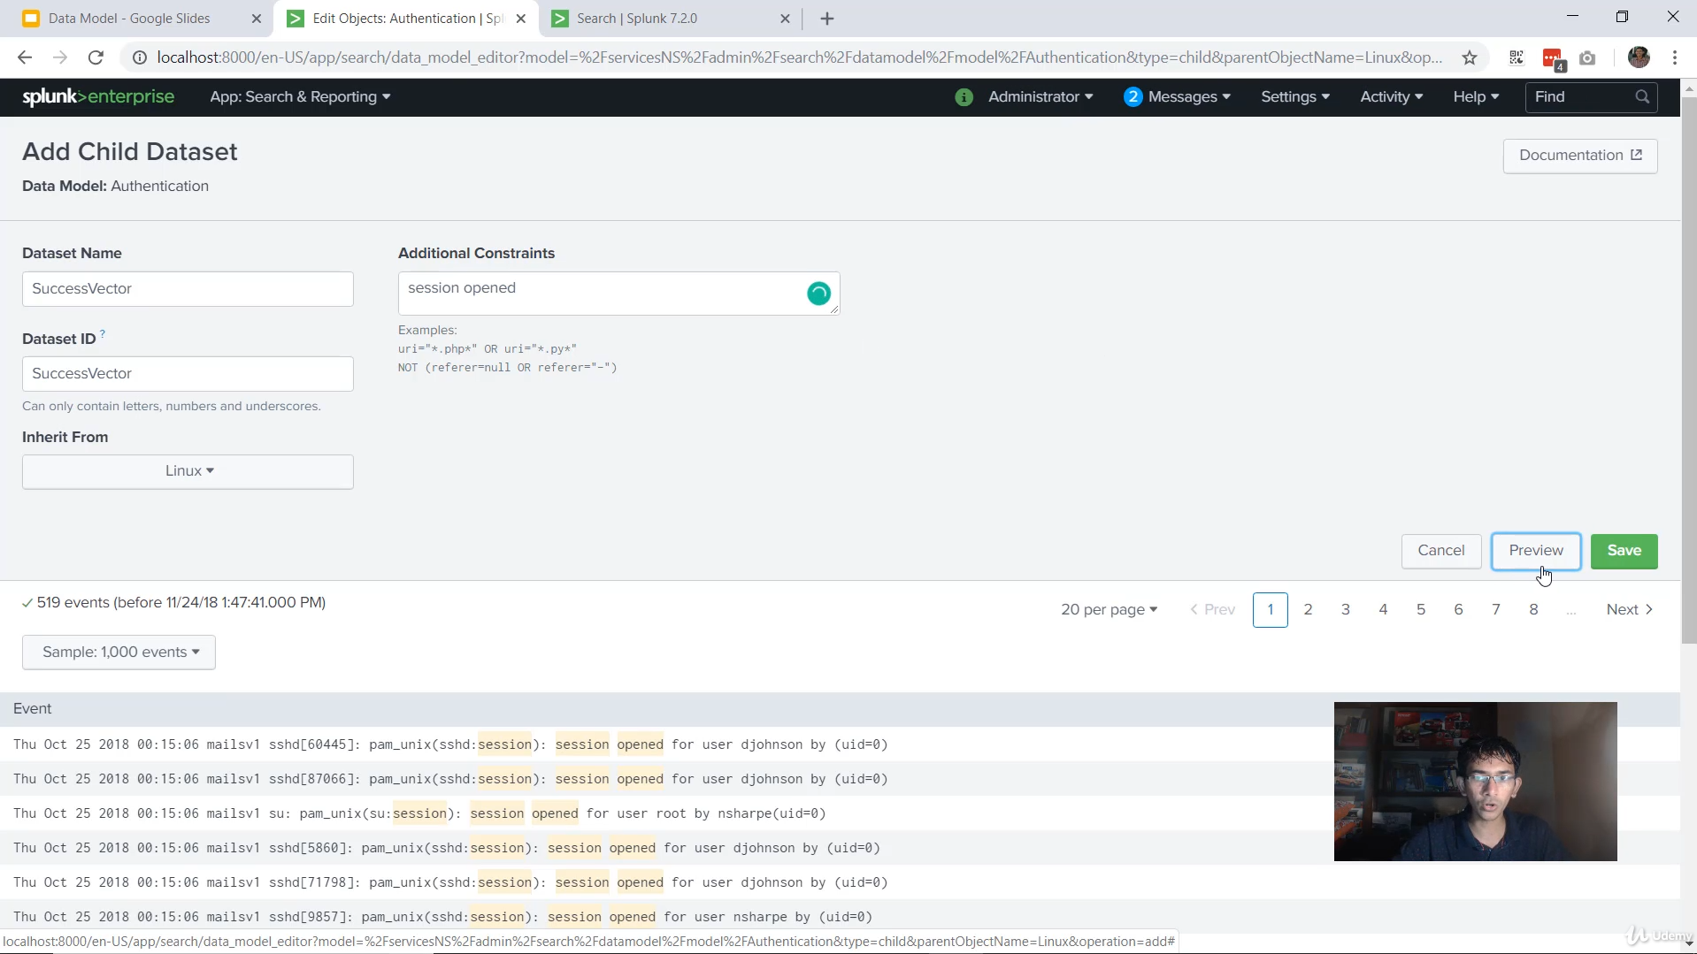

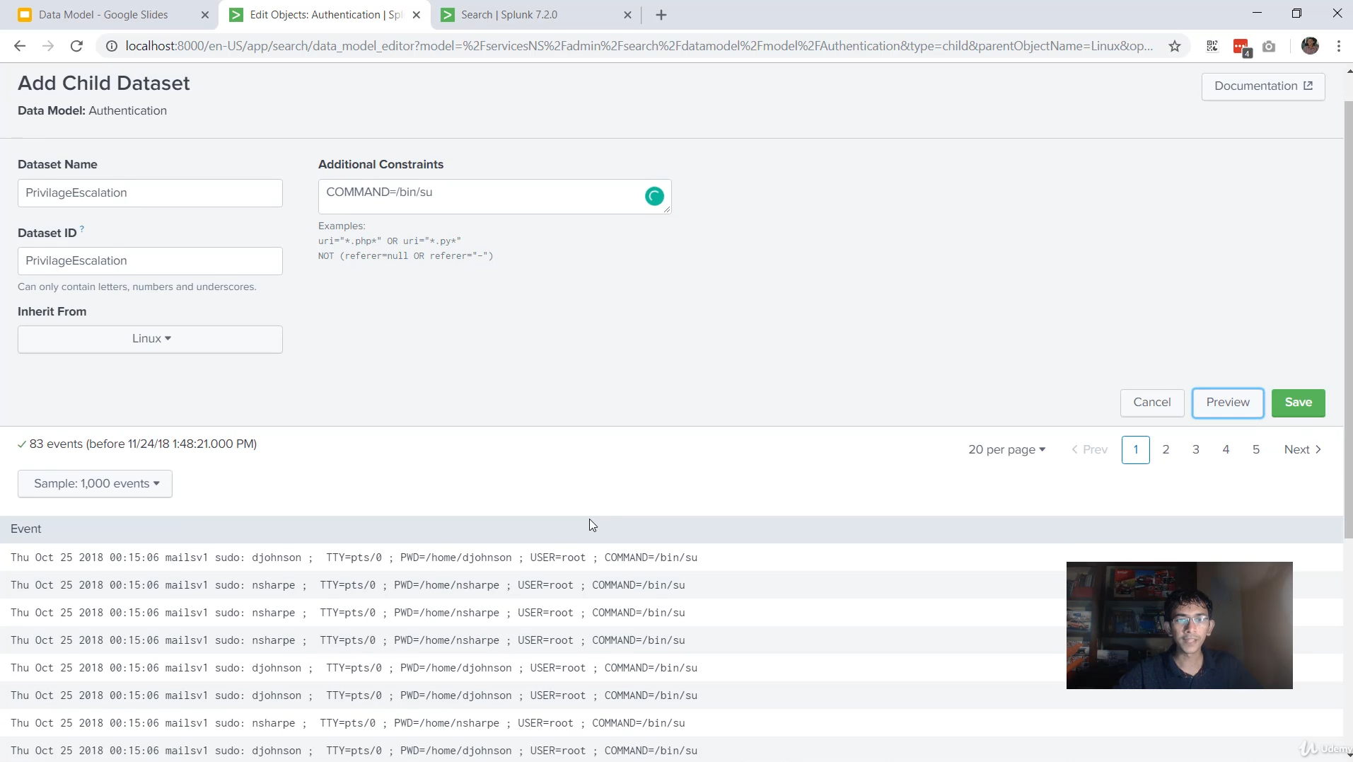

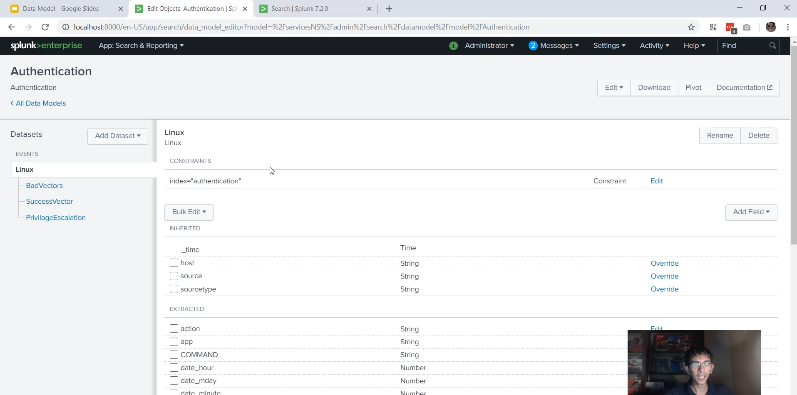

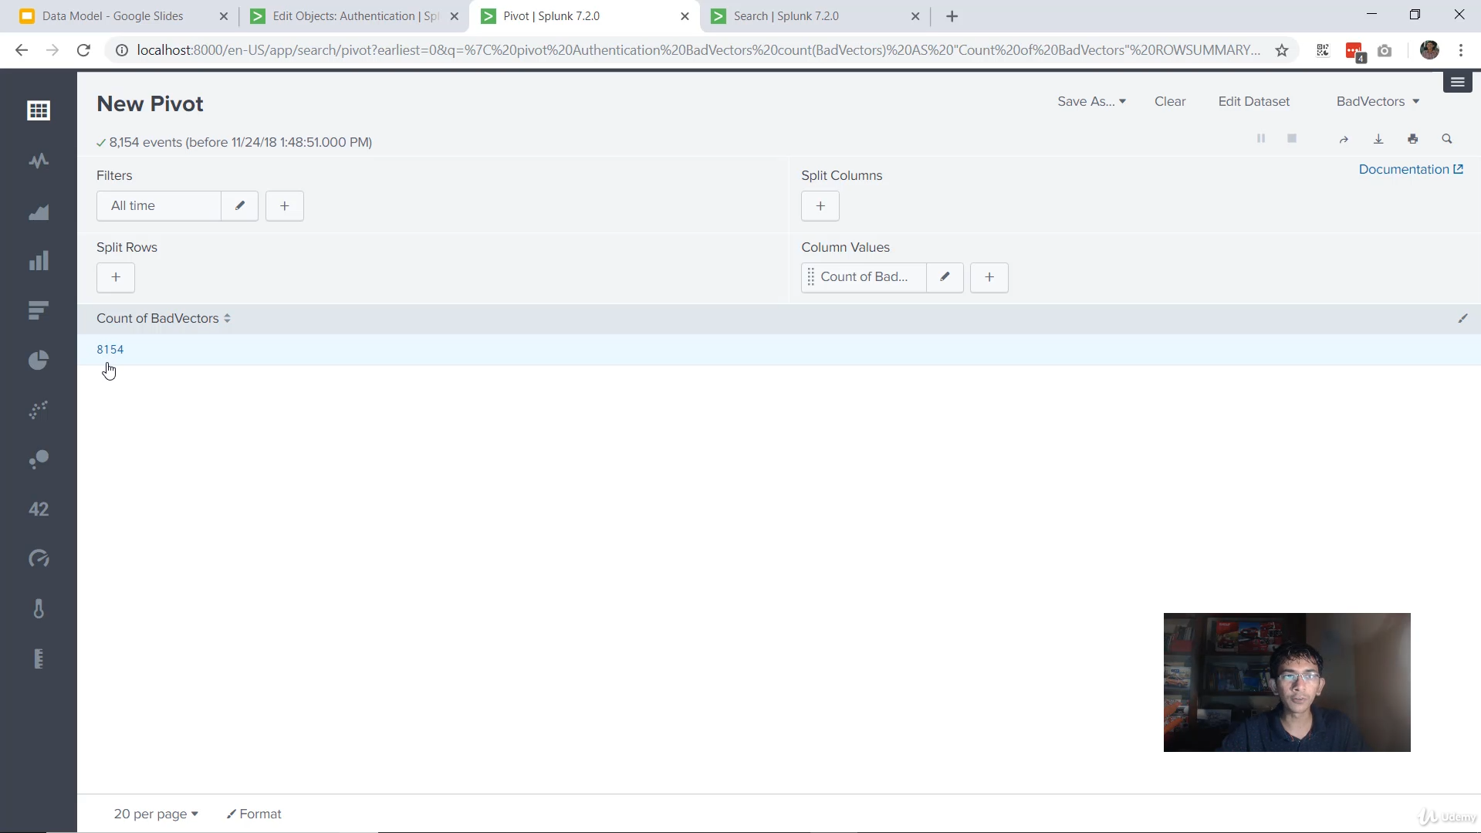

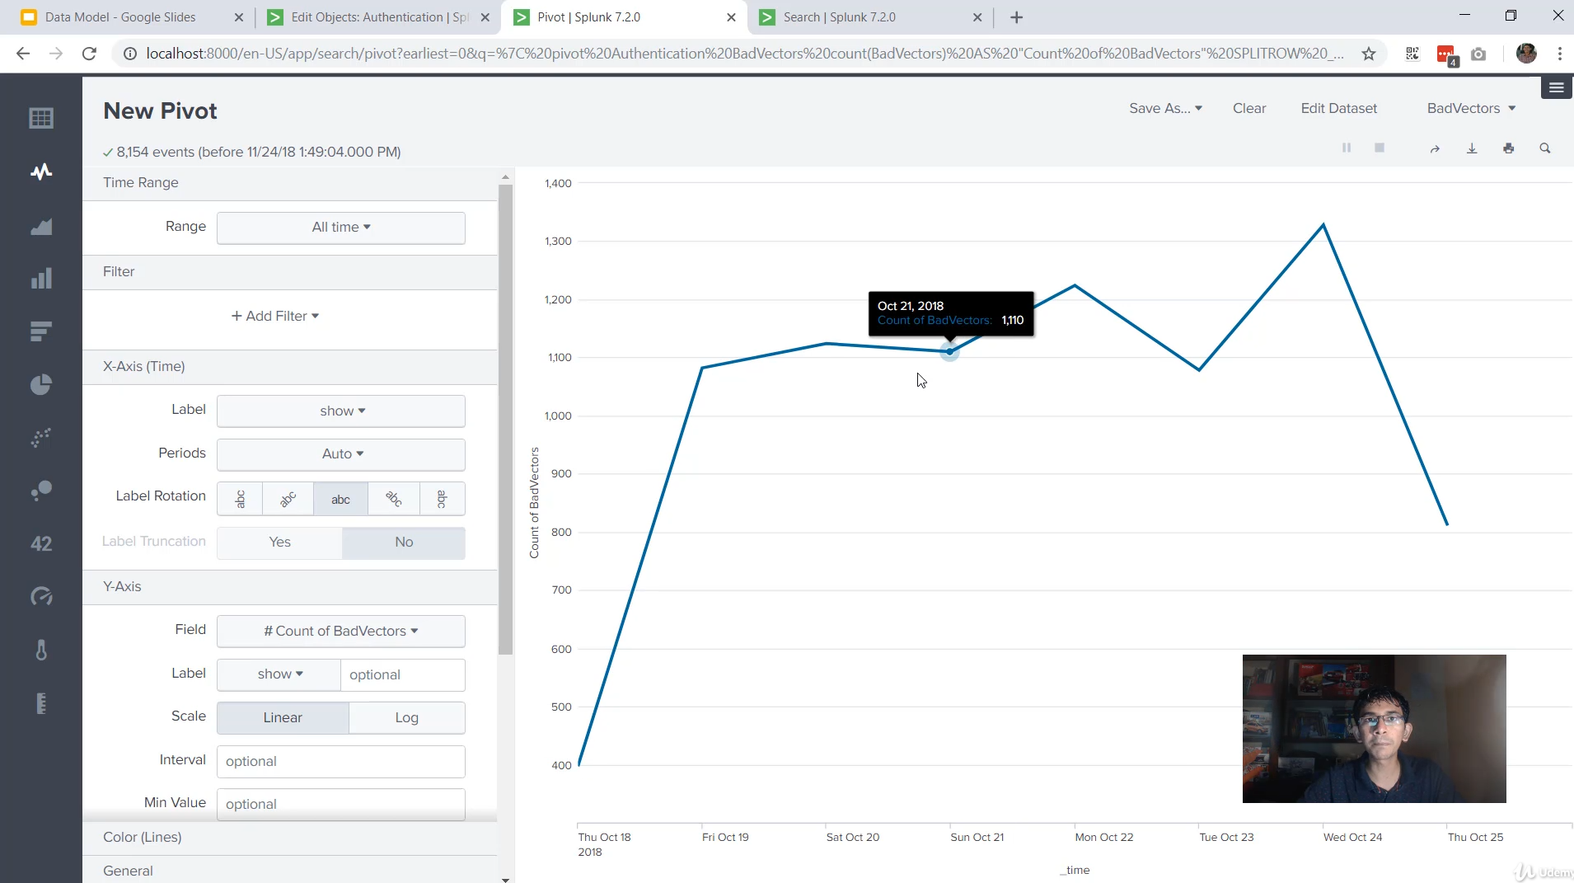

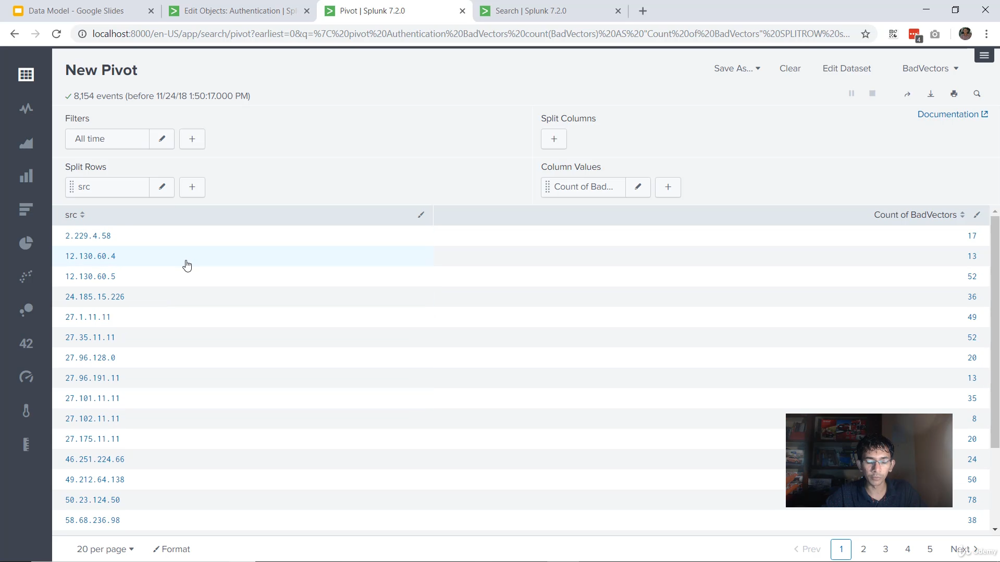

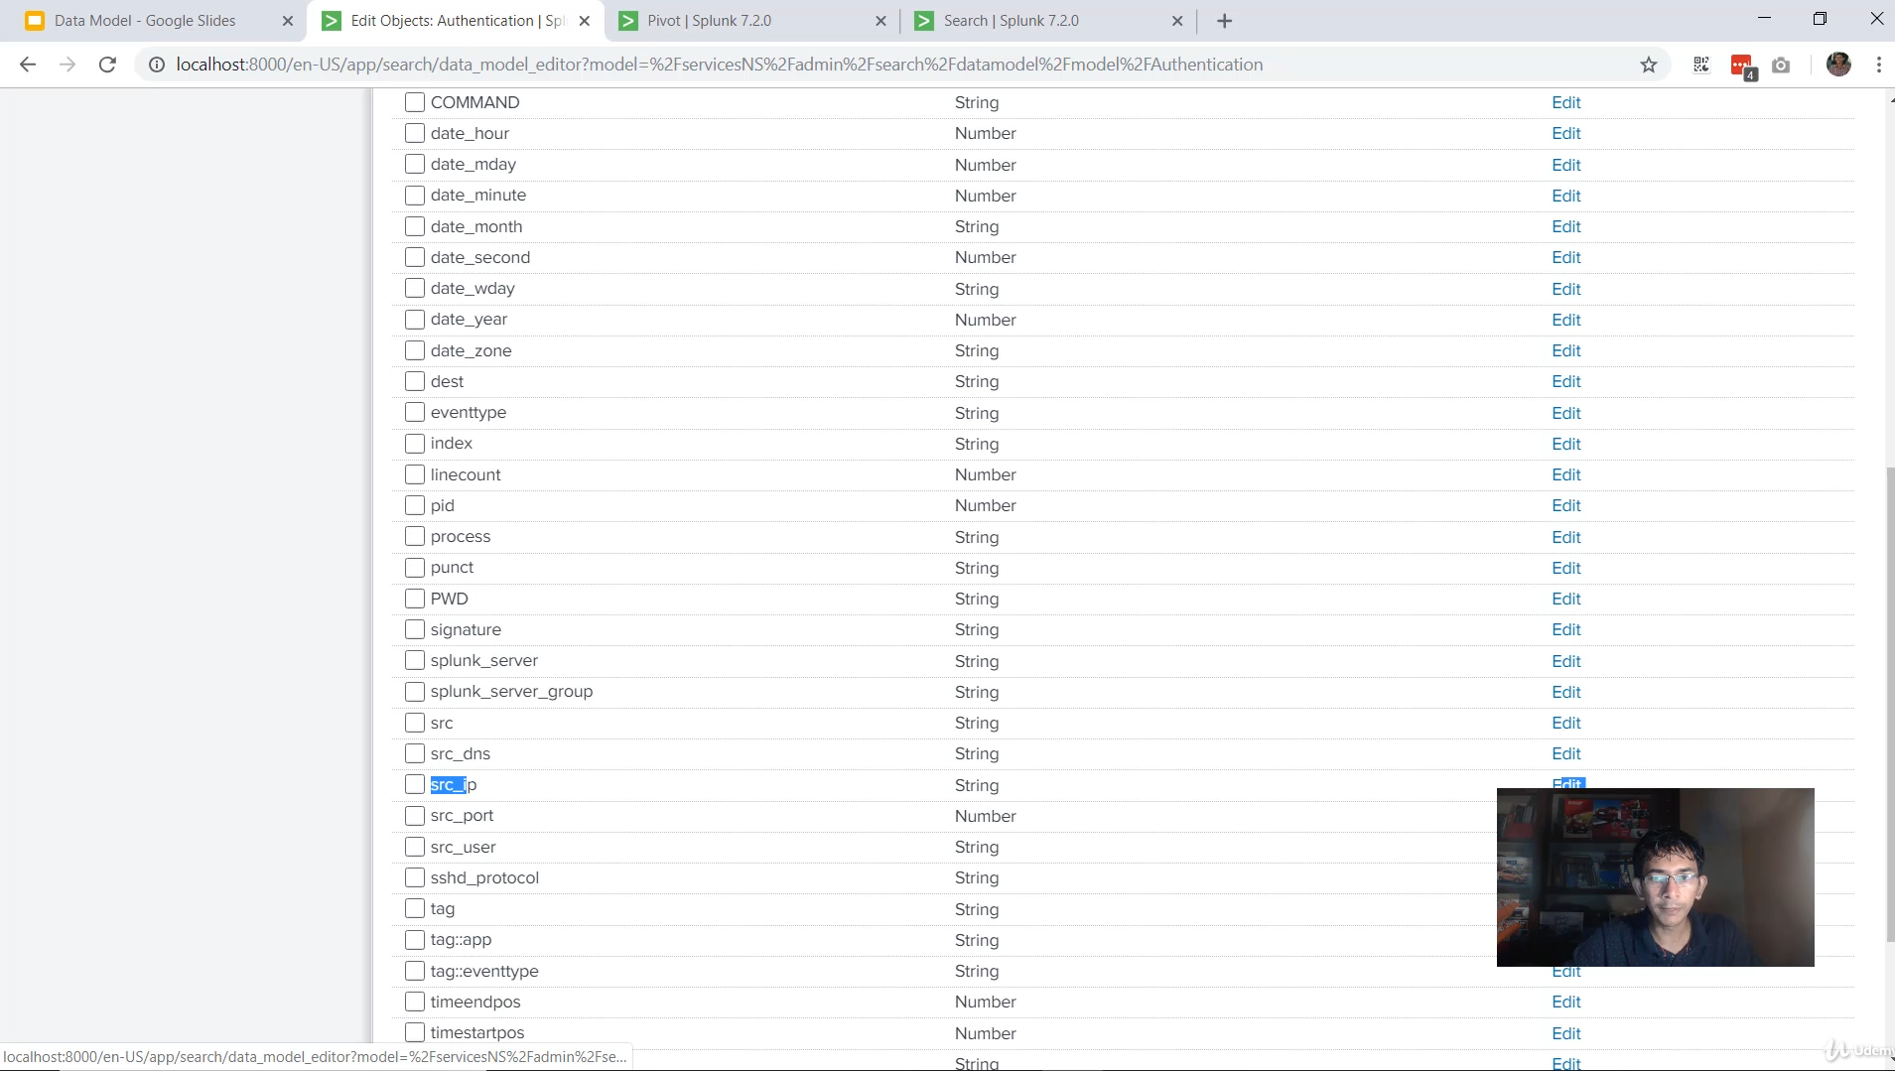

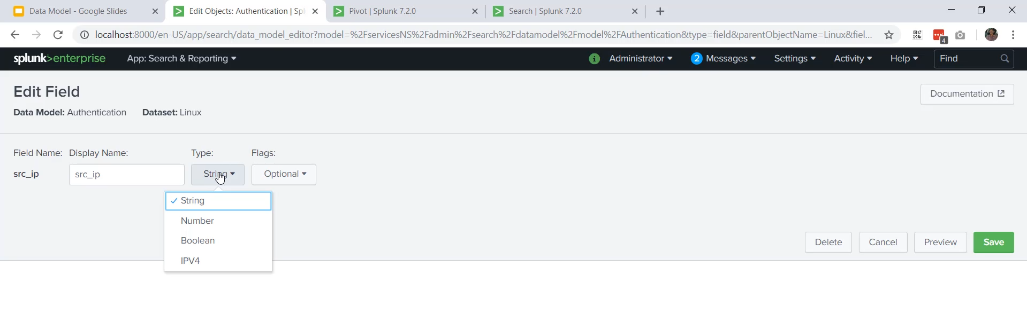

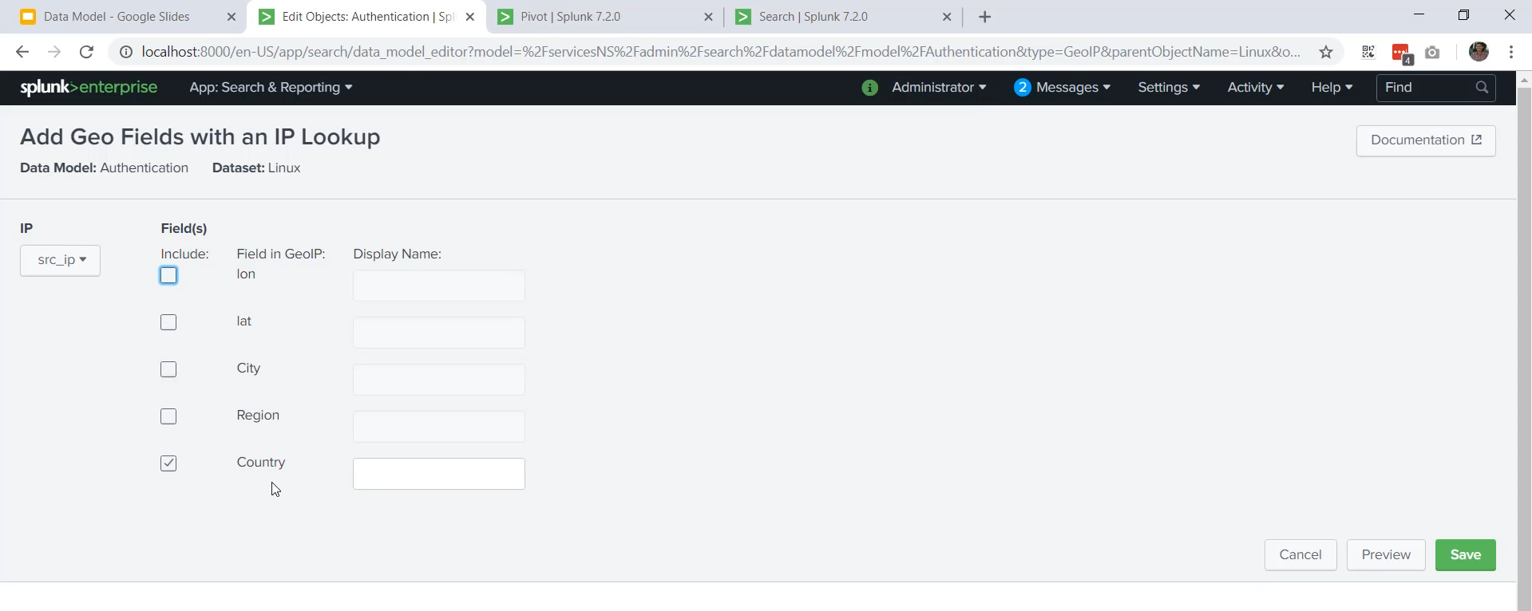

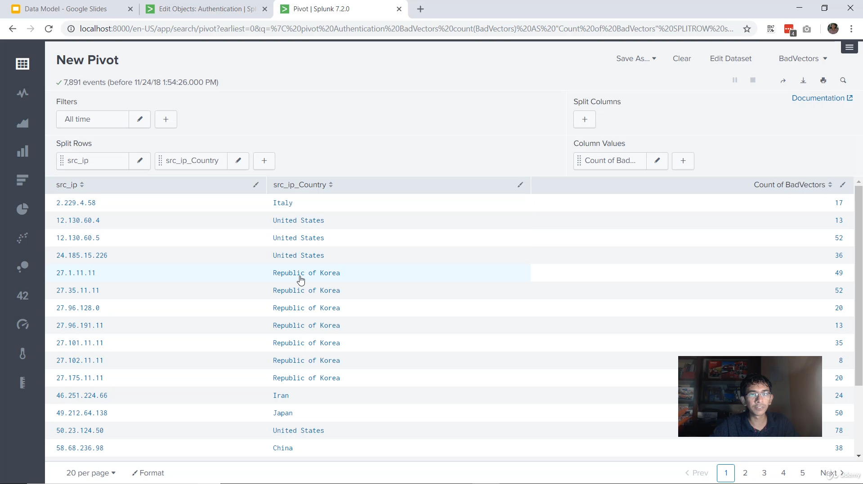

**Step-by-Step Data Model Implementation**

This video provided a practical guide on creating a Splunk Data Model, adding data, defining datasets, and using the resulting Pivot interface for non-SPL analysis.

**1. Initial Setup and Data Ingestion**

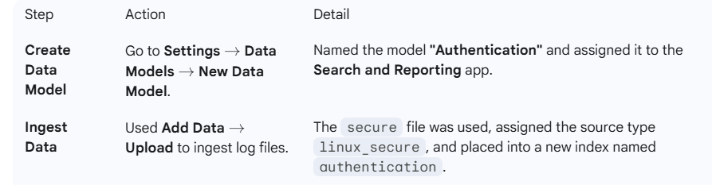

**2. Building the Data Model Hierarchy**

The core of the data model is defining a structured hierarchy using datasets:

**A. The Root Event Dataset (Base Data)**

* **Type:** **Root Event** (used for simple data definitions without complex pipes/commands).
* **Name:** Linux
* **Constraint:** index=authentication (This defines the base data for the entire model).
* **Field Extraction:** Used the **Auto Extract Fields** option to pull all available fields from the base data into the data model structure.

**B. Child Datasets (Use Cases)**

Three **Child Datasets** were created under the root, each representing a specific authentication use case:

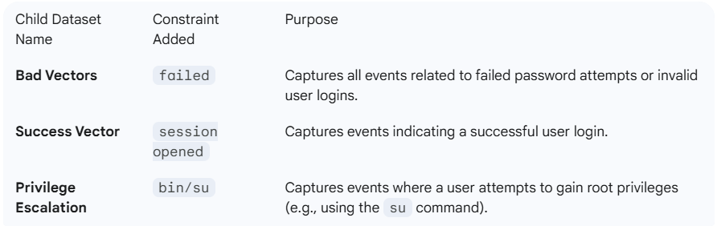

That was a fantastic, practical demonstration of creating and utilizing a Splunk Data Model! The detailed steps on building the hierarchy and enabling the Geo IP feature are excellent for understanding the utility of data models.

Here is the summarized breakdown of the data model creation and implementation process:

**🛠️ Step-by-Step Data Model Implementation**

This video provided a practical guide on creating a Splunk Data Model, adding data, defining datasets, and using the resulting Pivot interface for non-SPL analysis.

**1. Initial Setup and Data Ingestion**

| **Step** | **Action** | **Detail** |
| --- | --- | --- |
| **Create Data Model** | Go to **Settings** $\rightarrow$ **Data Models** $\rightarrow$ **New Data Model**. | Named the model **"Authentication"** and assigned it to the **Search and Reporting** app. |
| **Ingest Data** | Used **Add Data** $\rightarrow$ **Upload** to ingest log files. | The secure file was used, assigned the source type **linux_secure**, and placed into a new index named **authentication**. |

**2. Building the Data Model Hierarchy**

The core of the data model is defining a structured hierarchy using datasets:

**A. The Root Event Dataset (Base Data)**

* **Type:** **Root Event** (used for simple data definitions without complex pipes/commands).
* **Name:** Linux
* **Constraint:** index=authentication (This defines the base data for the entire model).
* **Field Extraction:** Used the **Auto Extract Fields** option to pull all available fields from the base data into the data model structure.

**B. Child Datasets (Use Cases)**

Three **Child Datasets** were created under the root, each representing a specific authentication use case:

| **Child Dataset Name** | **Constraint Added** | **Purpose** |
| --- | --- | --- |
| **Bad Vectors** | failed | Captures all events related to failed password attempts or invalid user logins. |
| **Success Vector** | session opened | Captures events indicating a successful user login. |
| **Privilege Escalation** | bin/su | Captures events where a user attempts to gain root privileges (e.g., using the su command). |

**3. Enhancing the Model with Geo IP**

To add geographic context without requiring users to write the iplocation command, the Geo IP feature was enabled:

1. **Identify IP Field:** The src_ip field was identified as the field containing the source IP address in the raw events.
2. **Change Field Type:** The src_ip field's type was **edited from string to IPV4** (Geo IP only works on IP-typed fields).
3. **Add Geo IP Field:** Under **Add Fields** $\rightarrow$ **Geo IP**, the src_ip field was selected, and **country** was added as a new extracted field (src_country).

**4. Utilizing the Model (Pivoting)**

The completed model is used via the **Pivot** interface, enabling non-SPL analysis:

* **Access:** Right-clicked on a child dataset (e.g., "Bad Vector") and selected **Pivot**.
* **Initial View:** The Pivot table instantly displayed the total count of events (e.g., 8154 bad vectors) and basic charts (e.g., count by time).
* **Custom Analysis:**
  + **Splitting Rows:** Used the **Split Rows** option to group events by a field, such as src_ip, to see which IP addresses had the highest bad vector counts.
  + **Adding Context:** Added the newly created **src_country** field to the table to visually determine the geographic origin of the failed logins (e.g., Italy, United States, Republic of Korea).
* **Saving Analysis:** The resulting tables and visualizations can be saved as a **Report** or **Dashboard Panel**.

**5. Portability**

* The created Data Model is an object that can be **downloaded** and then **uploaded** to a different Splunk instance, transferring the entire structured definition and associated use cases.

**============================================================================**

1. **Splunk support programs:**

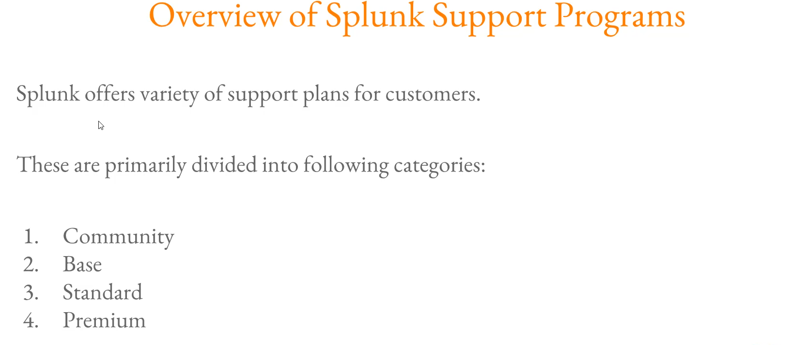

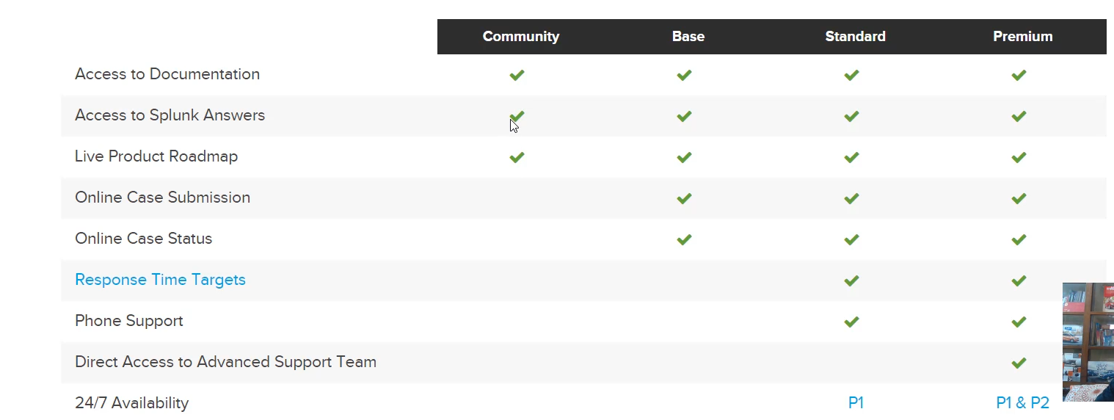

**Splunk Official Support Programs**

Splunk offers tiered support programs for its customers, ranging from community-driven assistance to high-priority enterprise support.

**1. Support Program Tiers**

Splunk primarily divides its support into four tiers. For enterprise environments, the **Standard** and **Premium** plans are the most relevant, as the others offer limited to no guaranteed response times.

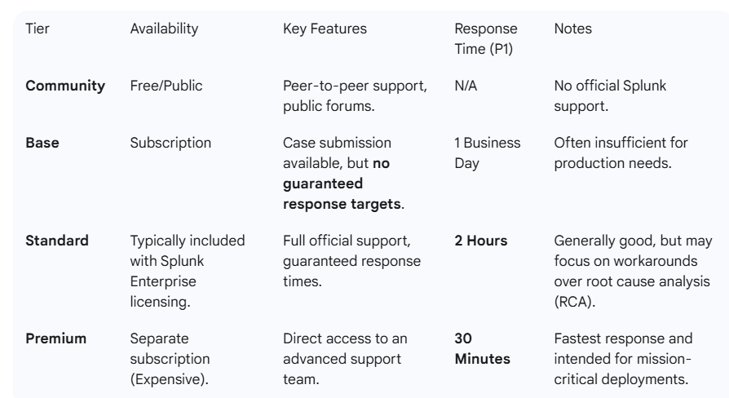

**2. Case Prioritization Levels**

When submitting a support case, the priority level dictates the urgency and the guaranteed response time. Assigning the correct priority is crucial; Splunk will downgrade the priority if it is mismatched with the actual issue's impact.

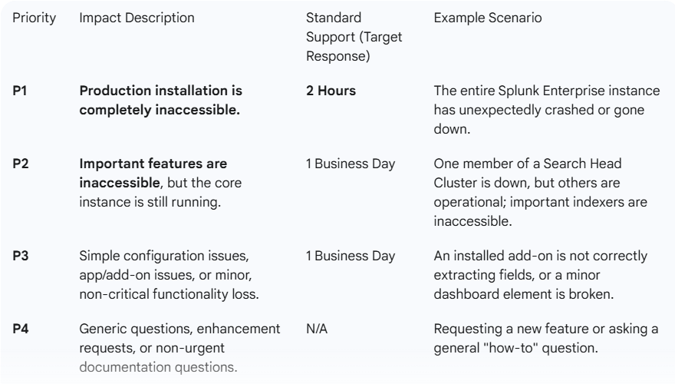

**3. Submitting a Support Case**

The process of submitting a new case through the Splunk Support Portal requires providing detailed, specific information to ensure the case is routed correctly:

1. **Select Priority:** Choose the appropriate level (P1 to P4).
2. **Product Selection:** Specify the product (e.g., Splunk Enterprise, Splunk Enterprise Security, Phantom/SOAR).
3. **Version and Category:** Select the product version and the area of the issue (e.g., Distributed Deployment, Authentication, Performance, Licensing).
4. **Component:** Select the exact component having the issue (e.g., Search Head Clustering, DMC, Forwarder Management).
5. **Environment Details:** Specify the operating system (e.g., Linux, Windows, Docker) and deployment type (Cloud or On-Premise).
6. **Description and Attachments:** Provide a detailed description, steps to reproduce the issue, and attach relevant files (like screenshots or a splunk diag file).

**\*\*\*\*\*\*\*\*\*\*\*\*\*\*\*\*\*\*\*\*\*\*\*\*\*\*\*\*\*\*\*\*\*\*\*\*\*\*\*\*\*\*\*\*\*\*\*\*\*\*\*\*\*\*\*\*\*\*\*\*\*\*\*\*\*\*\*\*\*\*\*\*\*\*\*\*\*\*\*\*\*\*\*\*\*\*\*\*\*\*\*\*\*\*\*\*\*\*\*\*\*\*\*\*\*\*\*\*\*\*\*\*\*\*\*\*\*\*\*\*\*\*\*\*\*\*\*\*\*\*\*\*\*\*\*\*\*\*\*\*\*\*\*\*\*\*\*\*\*\*\*\*\*\*\*\*\*\*\*\*\*\*\*\*\*\*\*\*\*\*\*\*\*\*\*\*\*\*\*\*\*\*\*\*\*\*\*\*\*\*\*\*\*\*\*\*\*\*\*\*\*\*\*\*\*\*\*\*\*\*\*\*\*\*\*\*\*\*\*\*\*\*\*\*\*\*\*\*\*\*\*\*\*\*\*\*\*\*\*\*\*\*\*\*\*\*\*\*\*\*\*\*\*\*\*\*\*\*\*\*\***